Milestone 3: Algorithms and Data Structures Enhancement Narrative
The artifact I've chosen is an implementation of an undirected, weighted Graph data structure in C++ which contains an implementation of Prim's minimum spanning tree algorithm. I originally wrote the Graph code in 2016 and Prim's algorithm was probably written in 2017.
I chose this artifact because it seemed like a reasonable choice for this category. I was considering enhancing a major project of mine, but any significant enhancement concerning algorithms and data structures in that code would have been too big of an endeavor. I was looking through my algorithms and data structures projects when I found a note I left in my Graph class. It said to redesign Prim's algorithm with a cleaner approach. There were also some notes regarding my thoughts on making the class compatible with Edges of char type vertices. That gave me the idea to make the class templated. The enhancement demonstrates my abilities with algorithms and data structures as I am rewriting an algorithm and improving a data structure to be more advanced.

The graph class was redesigned to be templated. The changes of the redesign permeated throughout the code including Prim's algorithm. The first iteration of work on this templated the graph vertices. The class and algorithm was tested with int and char types. I assumed should work with any type that implements the < operator. This is necessary for the nested STL maps, the underlying data structures which hold the data, to be able to order the values. Below are screenshots of successful runs with int and char types. The run with char is the same graph representation but with vertices A-F instead of 0-5. The input is in the form of v, w, weight.
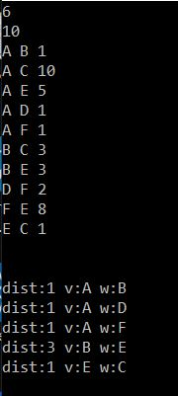
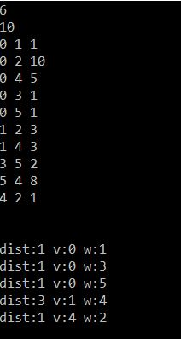
Prim's algorithm was rewritten with a cleaner approach. If we don't consider the necessary changes made due to redesigning the Graph class, the new approach is much more reasonable for me to implement during an interview. However, there is still one big piece of syntax that makes the algorithm look complex and I might not remember how to type up correctly during an interview. That is the declaration of the priority queue of pairs of int and Edge sorted in ascending order. The structure is complicated and to specify the ordering is verbose.
With the final publication, I decided to test the graph with a user-defined type and to make the edge weight templated as well. I realized that it wasn't just going to work with user-defined types that overloaded < operator. The types also needed a hash function, == operator, and a copy constructor. Templated edge weight is also complicated. It needs to behave numerically to an extent. If it was getting the sum of the edge weight it would need even more numerical behavior, but it isn't doing that so it can get by with partial numerical behavior. This means it needs a constructor that takes int and initializes to some conceptual minimum value. The user-defined edge weight also needs to overload the < and = operators, and needs a copy constructor. I could have just specified builtin numerical types to keep this simple, but this was more interesting. The code all looks very complicated now, but without all the template code there is still a easy-to-follow implementation of Prim's algorithm.

Below, tests of the new changes are shown. The implementation of the user-defined class and weight types can be found in main.cpp. The first test used a char as weight, the second used a user-defined weight type. The weight type holds a string, but the compares their “numerical” value by summing the ASCII values of the chars and multiplies by two when encountering an 'x'. The weight could have just used string comparison, but this was more interesting. The both sets of test cases result in the same edges being selected as the weights have the same relative rank within each respective set of weights.

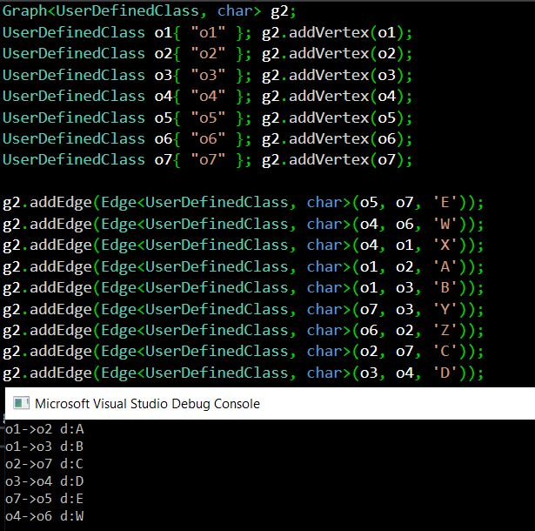

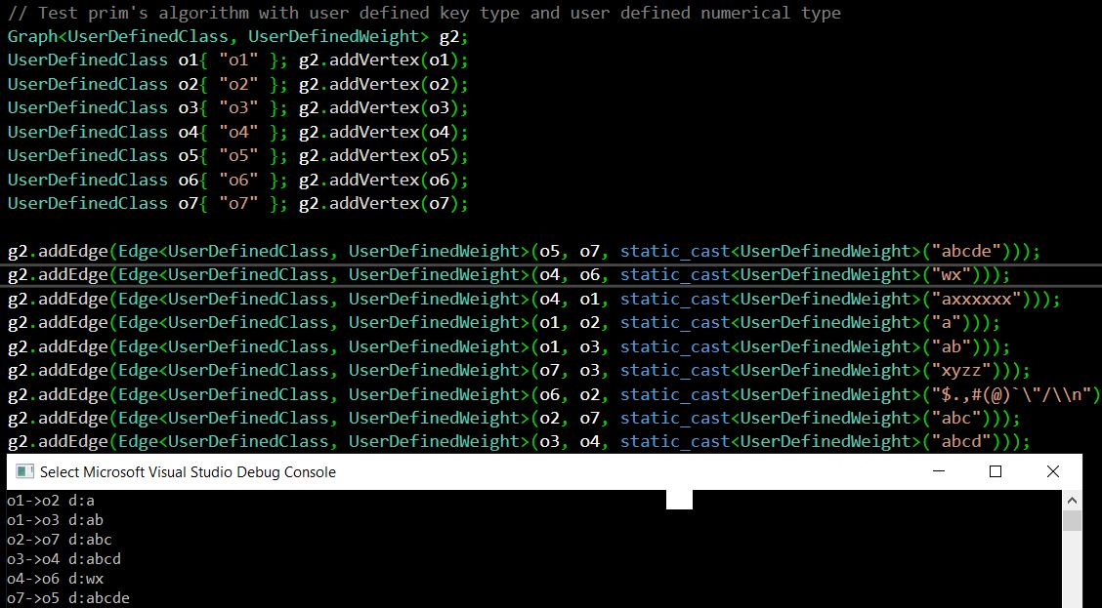

Although I was mostly working with familiar concepts, there was significant review and deepening of understanding. I had not worked with implementing C++ template class or functions and not with this graph class for two years some of the reviewing felt like learning. For example, I was stuck for a while because I forgot that template classes must have all their function definitions in the header file. Furthermore, I had not previously fully realized what it would take to switch the class and algorithm to using templates and now I know. However, there was considerable learning of C++ template insights as I did some complicated work with them. Although, I knew I could do this, I had not spent enough time thinking about what it required, or at least I had not recently done so. For example, I did not anticipate that I would need to change the underlying structure of the graph to be a map of maps, but I remember that is something I had done elsewhere in the past. While writing the Prim's algorithm code, I kept making mistakes based on the wrong assumptions, this made me realize I did not ever have a clear enough understanding of Prim's algorithm, even though I had implemented it multiple times in the past. In the past, I used techniques that were less optimal and required less thinking. With this current implementation, I spent much more time considering the complexity and trying to come up with a cleaner and optimal solution.
This work has illustrated the course objective I planned for, CS-499-03, and the concepts I planned for. The Graph class is a data structure and Prim's algorithm is a challenging algorithm, so by doing significant work with this code I've displayed a keen understanding of these concepts. Writing template classes is an advanced topic of C++, which was especially challenging given that the underlying adjacency list was a complicated map of maps. Thus, my success with these changes displayed advanced C++ knowledge.

